**COMET BAY COLLEGE**

**Physics Unit 3 - Task 2**

**Motion and Gravity Test 1**

**Name: SOLUTION Total Marks /63**

**All questions must be answered and to WACE specifications**

**Question 1**

The diagram shows a bobsled in motion along a frictionless ice track. When it is following the arc of a horizontal circle it tilts from an upright position as shown. The direction of the normal reaction force is shown.

**Bobsled – in motion out of the page and following a horizontal circular curve to the left**

**Normal reaction force**

**Ice track of curved profile**

**W = mg**

**mv2/ r**

1. For a bobsled of mass 3.50 × 102 kg calculate the magnitude of the normal reaction force required to maintain a horizontal circular path of radius 75.2 m at a speed of 86.4 **km per hour**. (4 marks)

**r = 75.2 m v = 86.4/3.6 = 24 m s-1 m = 350 kg (1 mark)**

**By Pythagoras**

**N = correct vector analysis (1 mark)**

**N = (1 mark)**

**N = 4353.37 = 4.35 x 103 N (1 mark)**

1. Calculate the angle (θ) from the vertical that that bobsled must lean in order to achieve this motion. (2 marks)

**(1 mark)**

**(1 mark)**

**Question 2**

What would be the distance of a free falling rock 5.0 seconds after falling from rest?

**u = 0 (1 mark) s = ut + ½ at2**

**a = 9.8 ms-2 s = 0 + ½ x 9.8 x 52 (1 mark)**

**t = 5 s s = 122.5 m 3 sig fig (1 mark)**

(3 marks)

**Question 3**

The acceleration of a body plotted against time is given by the diagram below.

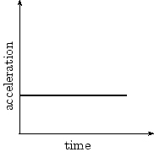

Draw the corresponding graphs in the space provided for: (3 marks)

a) velocity against time b) displacement against time

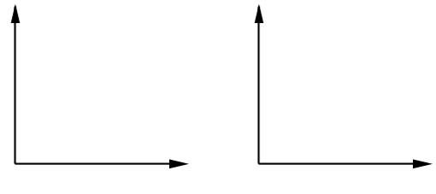

**(1 mark straight line) (1 mark curved line)**

**(1 mark concave up)**

**Question 4:**

A helicopter delivering supplies to a flood-stricken farm hovers 100 m above the ground. A package of supplies is dropped, just outside the door of the helicopter. Air resistance can be ignored. Calculate how long it takes the package to reach the ground. (3 marks)

**u = 0 (1 mark) s = ut + ½ at2**

**a = 9.8 ms-2 100 = 0 + ½ x 9.8 x t2 (1 mark)**

**s = 100 m t2 = = 20.41**

**t = 4.52 s (1 mark)**

**Question 5**

By banking the curves of racetracks it is possible for vehicles to turn in a horizontal circle without relying on friction. For a car of mass 2100 kg the angle of banking is set at 16.0° above the horizontal. The car drives at a speed 24.0 m s-1 to maintain its height on the bank.

**Vector diagram**

**ΣF**

16.0°

**Weight**

**= mg**

**Normal Reaction**

**16º**

1. Draw a vector diagram in the space above showing the forces acting on the car and the sum of those forces. (1 mark)
2. Calculate the horizontal radius of the car’s path. (3 marks)

**ΣF = mv2/r**

**tan 16º = (mv2/ r) / (mg) (1 mark)**

**tan 16º = (v2/ gr)**

**r = v2 / g.tan 16º (1 mark)**

**r = 242 / 9.8.tan 16º**

**r = 205 m (1 mark)**

1. The speed of the car increases to greater than 24.0 m s-1. Explain what other change must occur if the magnitude of forces on your vector diagram remain the same on this frictionless track. (2 marks)

**If ΣF = mv2/r is fixed (1 mark)**

**then as v increases the radius must increase as well. (1 mark)**

**(The car will move to a position higher up the track)**

**Question 6**

A skateboarder (mass 60 kg) enters the half-pipe at point A, as shown in the figure below. (Assume the frictional forces are negligible.)

1. Given the skateboarder's speed at point B is 8.9 m s-1, what is the centripetal force on the skateboarder at B? (2 marks)

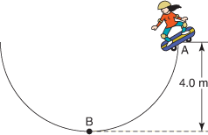

**m = 60 kg,**

**r = 4.0 m,**

**v = 8.9 m s-1**

**F = = (1 mark)**

**F = 1188 N (up) (1 mark)**

1. What is the normal reaction force on the skateboarder at B? (3 marks)

**Fnet = N – W (normal reaction force minus weight)**

**Fnet = Fcentripetal**

**Fcentripetal = N – W (1 mark)**

**N = Fcentripetal + W**

**N = 1188 + 60 × 9.81 (1 mark)**

**N = 1776.75 N upwards (1 mark)**

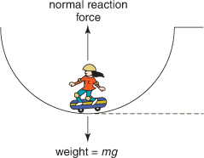

**Question 7**

An ice hockey puck slides at 21.0 m s-1 South-West, hits a goal post and rebounds at 20.0 m s-1 North-West. Calculate the change in velocity of the ice hockey puck. You must refer to a vector diagram and state both magnitude and direction in your response. (4 marks)

**Δv = v + (-u) as shown in 2D diagram (1 mark)**

**= 29.0 m s-1 (1 mark)**

**θ = tan-1(21/20) (1 mark)**

**= 46.4° = true bearing 1.40° or N 1.40° E (1 mark)**

**-u = 21 North East**

**v = 20 North West**

**θ°**

**Δv = v + (-u)**

**Question 8**

Isabella has got her football stuck in a tree. She throws her shoe at the tree to try and dislodge the football. The shoe is launched at an angle θ to the horizontal. The shoe reaches its maximum height of 5.10 m above the ground, continues and then gets stuck in the tree at a horizontal distance of 4.00 m in front of her. The flight time from the launch position to arriving at the tree was 0.950 s.

**Maximum height = 5.10 m**

**Range = 4.00 m**

**Isabella releases shoe at 1.90 m above ground**

**θ**

**Initial launch speed u**

1. Calculate the initial velocity of the shoe. Note that this is a vector quantity. (6 marks)

**Let up be positive (or alternative defined reference frame)**

**u (vertical) = u.sin θ (up)**

**at max height sv = 5.10 – 1.90 = +3.20 m above launch (1 mark)**

**v2 = uv2 + 2asv**

**0 = uv2 – (19.6 x 3.20) (1 mark)**

**uv = +7.92 m s-1  up (1 mark)**

**Consider horizontal t = 0.95 s sh = +4.00 m**

**uh = sh / t = 4 / 0.95 = 4.21 m s-1 right (1 mark)**

**By Pythagoras u = (uv2 + uh2)0.5 = (7.922 + 4.212)0.5 = 8.97 m s-1 (1 mark)**

**Elevation Angle = tan-1 (uv / uh)**

**= tan-1 (7.92/ 4.21) = 62.0° above horizontal (1 mark)**

1. Calculate the height above ground of the shoe when it became stuck in the tree. If you could not solve for the initial velocity u then use a value of 8.97 m s-1 at 62.0° above the horizontal. (3 marks)

**u (vertical) = u.sin θ (up) = 8.97 x sin 62 = +7.92 m s-1**

**t (flight) = 0.950 s a = -9.80 m s-1**

**s = ut + ½ at2**

**s = (7.92 x 0.95) – (4.9 x 0.952) (1 mark)**

**s = +3.10 m (1 mark)**

**Height of shoe = 1.90 + 3.10 = 5.00 m (1 mark)**

**Question 9**

During a game of totem tennis a ball of mass 60.0 g swings freely in a horizontal circular path. The string is 1.30 m long and is at an angle of 45o to the vertical as shown in the diagram.



1. Calculate the radius of the ball’s circular path. (2 marks)

**Radius = sin45o x 1.3 (1 mark)**

**= 0.92 m (1 mark)**

1. Calculate the net force acting on the ball (3 marks)

**Fg = m g = (60 x 10-3) x 9.8 = 0.588 N (1 mark)**

**Fc = (0.588 x tan 45o) = 0.588 N towards the centre (1 mark)**

**Net force (R)**

**R2 = 0.5882 + 0.5882**

**R = 0.832 N (1 mark)**

**Question 10**

Bob and Joe, on military service in an undisclosed location, are collecting supplies that have been dropped off at the beach. The supplies are contained in barrels and vary in mass from 410 kg to 530 kg. These barrels need to be quickly loaded onto the back of a jeep, but OS&H policies do not allow them to deadlift the items, unless under attack. So they bring a 3 metre plank along which will create an angle of 32o from horizontal when rested against the back of the jeep.

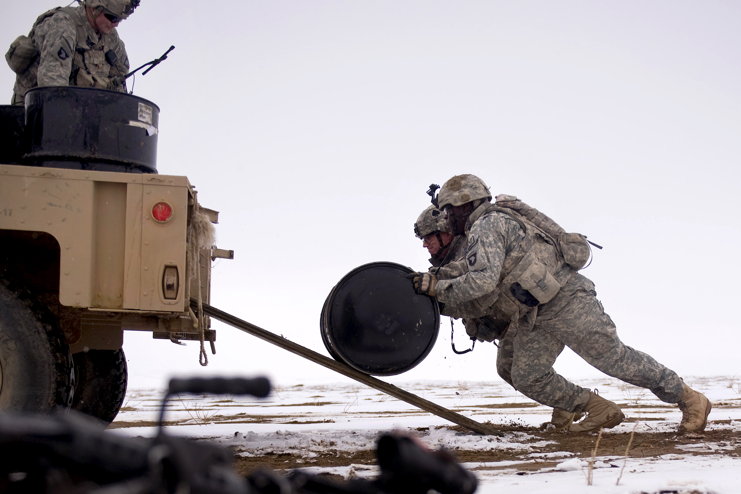

1. Draw a vector diagram, showing all forces when the barrel is halfway up this nearly frictionless plank. (2 marks)

**1 mark for arrows pointed in correct direction (and/or negative sign)**

**1 mark for angle positioned in correct location**

**-F**

**W**

**-N**

**32o**

**32o**

**F**

**N**

**W**

1. If the plank can support a mass of 450 kg, can they safely roll the barrels up the plank? Use calculations to support your answer. (3 marks)

**m = 530 kg (1 mark for trialling the heaviest barrel only)**

**cos θ = N /W**

**N = W cos 32**

**= 530 cos 32 (1 mark)**

**= 449 N**

**Yes, if it can support the heaviest barrel, then it can support all the barrels (one at a time) (1 mark)**

**Question 11**

The graph below shows the speed of two cars.

**Speed (m s-1)**

**Time (s)**

The speed limit in the vicinity of the two cars is 90 km h-1

1. By how much is the speeding car exceeding the speed limit? Give your answer in km h-1.

(2 marks)

**v = 35 x = 126 km h-1 (1 mark)**

**Hence speeding by 126 – 90 = 36 km h-1 (1 mark)**

1. The police car gives chase to the speeding car 10 seconds after it passes. What is the acceleration of the police car at time t = 45 seconds on the graph? (2 marks)

**a = = (1 mark)**

**a = 0.83 m s-2 (1 mark)**

1. Using the graph, calculate whether the police car has passed the speeding car by the time in the 100 seconds shown. (6 marks)

**scar = v x t spc1: 10 to 70 seconds**

**scar = 35 x 100 spc1 = ut + ½ at2**

**scar = 3500m (1 mark) spc1 = 0 x 60 + ½ x 0.83 x 602 (1 mark)**

**spc1 = 1494 m (1 mark)**

**spc2: 70 to 100 seconds**

**spc2 = v x t = 50 x 30**

**spc2 = 1500 m (1 mark)**

**spctotal = 1494 + 1500 = 2994 m (1 mark)**

**Hence police car does not catch up to speeding car in the first 100 seconds. (1 mark)**

**Question 12**

A roller coaster car of mass 800 kg is going over the apex of a circular section of track. The car has a speed of 6.00 m s-1. Calculate the radius of the curve for the car to experience a normal reaction force of 4000 N from the track. You must refer to a vector diagram in your answer. (4 marks)

Roller coaster track

Roller coaster car

**Vector diagram**

**W = m.g**

**= 7840 N**

**Normal = 4000 N**

**ΣF = mv2/r**

**Vector diagram (1 mark)**

**W = 800 x 9.8 = 7840 N down**

**From vector diagram ΣF = 7840 – 4000 = 3840 N to centre (1 mark)**

**ΣF = mv2 / r = 3840 N**

**r = mv2 / ΣF**

**r = 800 x 62 / 3840 (1 mark)**

**= 7.50 m (1 mark)**

**(Or similar alternative derivations)**